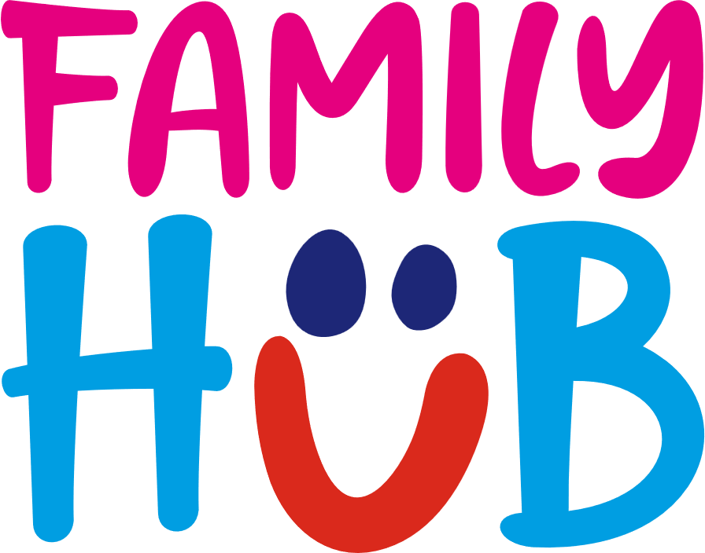

**Family Hubs Sunderland – social media content**

**Please tag** [**Sunderland Family Hubs**](https://www.facebook.com/SunderlandFamilyHubs) **on Facebook and** [**Family Hubs Sunderland**](https://www.instagram.com/familyhubssunderland?utm_source=ig_web_button_share_sheet&igsh=ZDNlZDc0MzIxNw==) **on Instagram**

**Social media post 1**Did you know there are five Family Hubs in Sunderland which support families from pregnancy through to your child's 19th birthday (or 25 if they have SEND needs)? 🍼👩‍👧‍👦

At each hub you will find:

✅ Expert advice and guidance  
✅ Free activities and play sessions   
✅ SEND-friendly support  
✅ A chance to connect with other families

Find your nearest hub and discover what is on offer at [Sunderland | My Best Life](https://www.mybestlife.org.uk/Sunderland-Family-Hubs)

**Suggested asset**

|  |  |
| --- | --- |
|  |  |
| **Facebook asset** | **Instagram asset** |

**Social media post 2**

Sunderland’s five Family Hubs support families of children aged up to 19, or to children with special educational needs and disabilities (SEND) aged up to 25. They bring together a mix of experts, professionals, and volunteers to create a friendly space for families, offering a range of support including midwifes, health visitors, infant feeding advisors, parenting and health classes and free educational, fun and interactive activities.

Find out more at [Sunderland | My Best Life](https://www.mybestlife.org.uk/Sunderland-Family-Hubs)

**Suggested asset**

|  |  |
| --- | --- |
|  |  |
| **Facebook asset** | **Instagram asset** |

**Social media post 3**

Whether your wanting playdates for your little ones, are looking for expert advice, or you’re hoping to meet people just like you, Family Hubs in Sunderland are here for you. At each hub you can connect to local resources, take part in free activities and events and find out about services that will help you and your family thrive.

Head over to [Sunderland | My Best Life](https://www.mybestlife.org.uk/Sunderland-Family-Hubs) to find out more.

**Suggested asset**

|  |  |
| --- | --- |
|  |  |
| **Facebook asset** | **Instagram asset** |

**Social media post 4**

Family Hubs across Sunderland are here to support families for free through:   
🎨 Fun activities and events  
🗨️ Expert advice for parents and carers   
🧩 Support for families with SEND or additional needs  
🤝 Opportunities to meet other families

From bump to big kids, Family Hubs are here to help your family thrive. Find out more at [Sunderland | My Best Life](https://www.mybestlife.org.uk/Sunderland-Family-Hubs) or visit one of the hubs for free.

**Suggested asset**

|  |  |
| --- | --- |
|  |  |
| **Facebook asset** | **Instagram asset** |

**Social media post 5**

With events and advice for all ages, Family Hubs offer free and exciting family-friendly activities and support services in Sunderland. Why not visit one of the hubs in the city to discover:

* Family friendly events for all ages
* Support through Family Hubs’ teams and volunteers
* Practical guidance and parenting support
* Connections to local resources and services

Be part of the local community through Sunderland’s Family Hubs – find out more at [Sunderland | My Best Life](https://www.mybestlife.org.uk/Sunderland-Family-Hubs) or pop into one of the hubs.

**Suggested asset**

|  |  |
| --- | --- |
|  |  |
| **Facebook asset** | **Instagram asset** |

NB: all assets can be used for other posts if preferred.