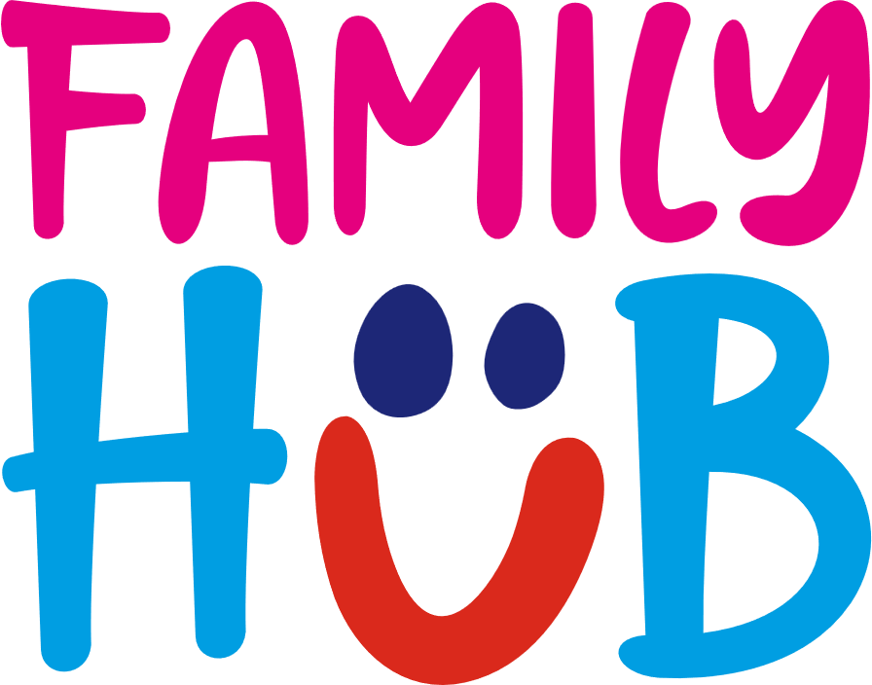

**Family Hubs Sunderland – newsletter content**

**[Longer newsletter copy]**

**Introducing Sunderland Family Hubs**

Sunderland’s five Family Hubs support families of children aged up to 19, or up to 25 for children with special educational needs and disabilities (SEND). They bring together a mix of experts, professionals, and volunteers to create a friendly space for families across Wearside through key stages of their lives.

At the core of every Family Hubs network, is a great Start for Life service which focuses on health and support all the way from conception through to a child being 2 years old. The first few years of a baby’s life are the most crucial in their development and this is the time in which they learn valuable skills - from talking to walking. These are the years that build the foundation of their life, and Family Hubs are on-hand to help families through the natural highs and lows of family life

The Family Hubs offer a range of support including midwifes, health visitors, infant feeding advice, parenting classes and free, interactive, and educational activities for children led by the Family Hub team.

There are five Family Hubs across Sunderland:

**Bunnyhill Family Hub**   
Hylton Lane, Sunderland, SR5 4BW  
0191 561 8126 / family.hubnorth@togetherforchildren.org.uk

**Coalfield Family Hub**  
Hetton Centre, Welfare Road, Hetton le Hole, DH5 9NE  
0191 561 4084 / family.hubhetton@togetherforchildren.org.uk

**Thorney Close Family Hub**  
120 Thorndale Road, Sunderland, SR3 4JQ  
0191 561 4127 / family.hubwest@togetherforchildren.org.uk

**Rainbow Family Hub**  
34 Elliott Terrace, Washington, NE37 3AE  
0191 561 3995 / family.hubwashington@togetherforchildren.org.uk

**Winnibell Family Hub** 1-4 Lombard Street, Hendon, Sunderland, SR1 2HS  
0191 561 2850 / [family.hubeast@togetherforchildren.org.uk](mailto:family.hubeast@togetherforchildren.org.uk)

Families can sign up to access Sunderland’s Family Hubs by completing the [Family Hub registration form.](https://www.togetherforchildren.org.uk/article/32202/Family-Hub-registration-form) You can also access information on the support, events and activities offered by the Family Hubs through [My Best Life.](https://www.mybestlife.org.uk/Sunderland-Family-Hubs)

**[Shorter newsletter copy]**

**Introducing Sunderland Family Hubs**

Sunderland’s network of Family Hubs are one stop shop of activities and support for families across the city. They offer a network of safe, confidential, and non-judgemental spaces for children and families from pregnancy up to the age of 19 (25 with special educational needs and disabilities). From parenting sessions and free activities to health services and birth registrations, you will find a community, the support and everything you need to help your family thrive.

There are five Family Hubs across Sunderland:

**Bunnyhill Family Hub**   
Hylton Lane, Sunderland, SR5 4BW

**Coalfield Family Hub**  
Hetton Centre, Welfare Road, Hetton le Hole, DH5 9NE

**Thorney Close Family Hub**  
120 Thorndale Road, Sunderland, SR3 4JQ

**Rainbow Family Hub**  
34 Elliott Terrace, Washington, NE37 3AE

**Winnibell Family Hub** 1-4 Lombard Street, Hendon, Sunderland, SR1 2HS

Families can sign up to access Sunderland’s Family Hubs by completing the [Family Hub registration form.](https://www.togetherforchildren.org.uk/article/32202/Family-Hub-registration-form) You can also access information on the support, events and activities offered by the Family Hubs through [My Best Life.](https://www.mybestlife.org.uk/Sunderland-Family-Hubs)