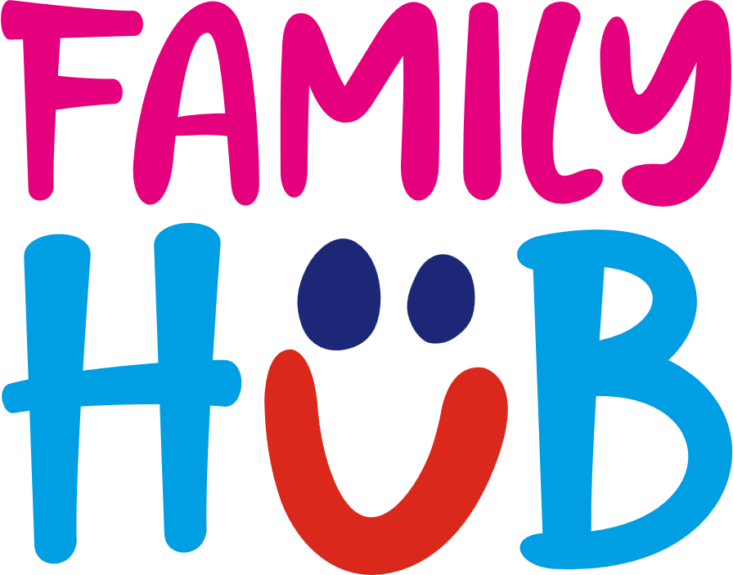

Sunderland Family Hub Super Communicator Referral Form (2025)

\***Each referral will be triaged. The family will then be offered the most appropriate session on the information supplied)**

|  |
| --- |
| Referrers name:  Job title and agency:  Contact number  Email address: |

|  |
| --- |
| Parent/Carers name:  Address:  Postcode:  Telephone number:  Email address:  Ethnicity: |

|  |  |  |
| --- | --- | --- |
| Child’s name: | Date of birth/Premature? | Additional needs/disabilities: |
|  |  |  |

|  |  |
| --- | --- |
| Allocated Professionals | Email address |
| Health Visitor – |  |
| Speech and Language Referral | Yes/ No |
| Nursery/School – |  |
| Paediatric referral | Yes/ No |

|  |  |  |
| --- | --- | --- |
| Session | Description | (Please tick required session) |
| **Super communicator session**  (18 month-3yrs) | 6 weeks termly programme- Early language session learning through play for 18 months to 3 yrs. |  |
| **Makaton**  (6 months- 4yrs) | 6-week programme providing a visual aid that can help babies and children understand the meaning of words and phrases.  6 months- 4yrs |  |

|  |
| --- |
| ________________________________________________________________________________  **Reason for referral (please let us know of referrals made to other agencies below)** |

* Parent/Carer Signature: ___________________________________
* Verbal Consent Provided: Yes / No
* Consent to Share Information: Yes / No
* Date: ___________________________________
* Referrer's Signature: ___________________________________

Please send completed forms to: [Claire.mcgowan@togetherforchildren.org.uk](mailto:Claire.mcgowan@togetherforchildren.org.uk)

